Name: **Maloth Aditya**

Roll No.: **120CS0124**

Q1) **Write Tcl script to create scenario and study the performance of token ring protocols through simulation. Create 6 nodes that forms a network numbered from 1 to 6. Create duplex links between the nodes to form a Ring Topology with bandwidth of 100 Mbps and delay of 2ms. Setup TCP Connection between node 1 and node 4. Apply FTP Traffic over TCP. Finish the transmission at 100 sec.**

**Code :**

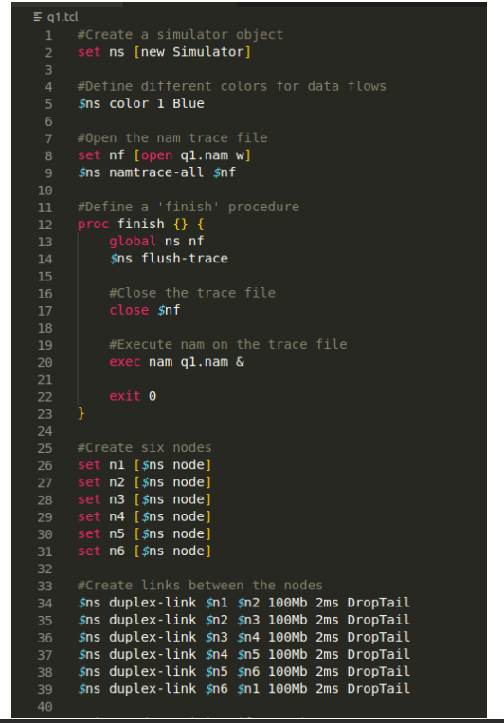

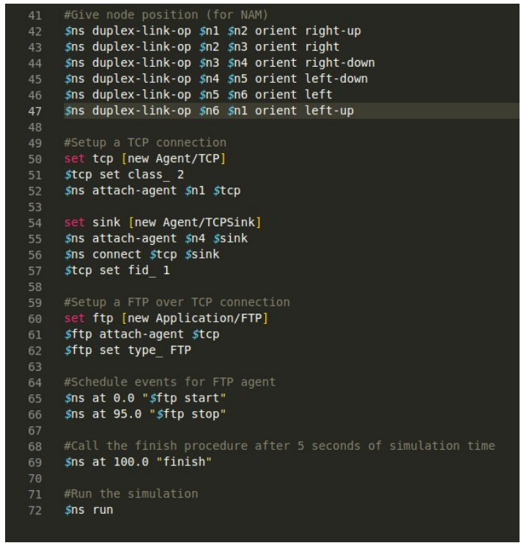

**Output :**

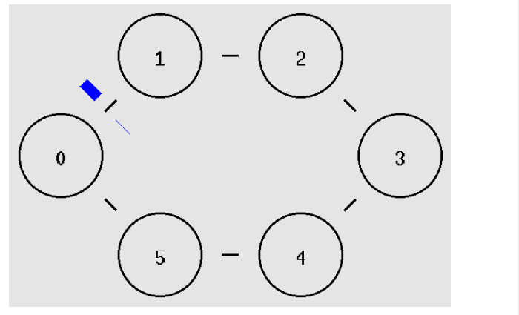

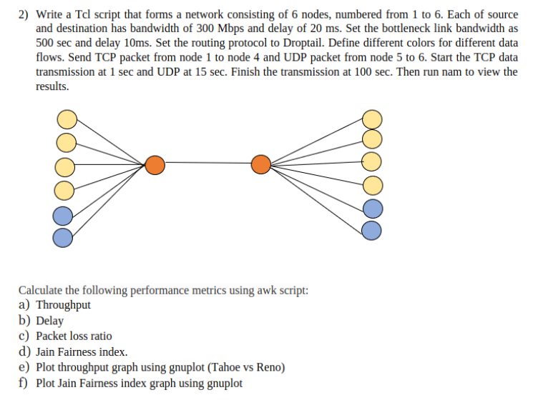

1. **Throughput .**

**--tahoe.tcl code ---**

**set** ns [new Simulator]

$ns color 1 Blue

$ns color 2 Red

$ns color 3 Yellow

$ns color 4 Pink

$ns color 5 Black

$ns color 6 Green

**set** tracefile [**open** tahoe.tr w]

$ns trace-all $tracefile

**set** namfile [**open** tahoe.nam w]

$ns namtrace-all $namfile

**for** {**set** i 0} {$i < 6} {**incr** i} {

**set** n($i) [$ns node]

}

**for** {**set** i 0} { $i < 6} {**incr** i} {

**set** r($i) [$ns node]

}

**set** b(0) [$ns node]

**set** b(1) [$ns node]

**for** {**set** i 0} { $i < 6} {**incr** i} {

$ns duplex-link $n($i) $b(0) 300Mb 20ms DropTail

}

$ns duplex-link $b(0) $b(1) 500Mb 10ms DropTail

**for** {**set** i 0} { $i < 6} {**incr** i} {

$ns duplex-link $r($i) $b(1) 300Mb 20ms DropTail

}

*#tcp setup*

**for** {**set** i 0} { $i < 4} {**incr** i} {

**set** tcp($i) [new Agent/TCP]

**set** sink($i) [new Agent/TCPSink]

$ns attach-agent $n($i) $tcp($i)

$ns attach-agent $r($i) $sink($i)

**set** ftp($i) [new Application/FTP]

$ftp($i) attach-agent $tcp($i)

$ns connect $tcp($i) $sink($i)

$tcp($i) set fid_ $i+1

}

*#udp setup*

**set** udp(0) [new Agent/UDP]

**set** udp(1) [new Agent/UDP]

**set** null(0) [new Agent/Null]

**set** null(1) [new Agent/Null]

$ns attach-agent $n(4) $udp(0)

$ns attach-agent $r(4) $null(0)

**set** cbr(0) [new Application/Traffic/CBR]

$cbr(0) attach-agent $udp(0)

$ns connect $udp(0) $null(0)

$udp(0) set fid_ 5

$ns attach-agent $n(5) $udp(1)

$ns attach-agent $r(5) $null(1)

**set** cbr(1) [new Application/Traffic/CBR]

$cbr(1) attach-agent $udp(1)

$ns connect $udp(1) $null(1)

$udp(1) set fid_ 6

 $ns at 1.0 "$ftp(0) start"

 $ns at 1.0 "$ftp(1) start"

 $ns at 1.0 "$ftp(2) start"

 $ns at 1.0 "$ftp(3) start"

 $ns at 15.0 "$cbr(0) start"

 $ns at 15.0 "$cbr(1) start"

$ns at 100.0 "finish"

**proc** finish {} {

**global** ns tracefile namfile

   $ns flush-trace

**close** $tracefile

**close** $namfile

**exit** 0

}

$ns run

--reno.tcl—

*#Reno*

**set** ns [new Simulator]

$ns color 1 Blue

$ns color 2 Red

$ns color 3 Yellow

$ns color 4 Pink

$ns color 5 Black

$ns color 6 Green

**set** tracefile [**open** reno.tr w]

$ns trace-all $tracefile

**set** namfile [**open** reno.nam w]

$ns namtrace-all $namfile

**for** {**set** i 0} {$i < 6} {**incr** i} {

**set** n($i) [$ns node]

}

**for** {**set** i 0} { $i < 6} {**incr** i} {

**set** r($i) [$ns node]

}

**set** b(0) [$ns node]

**set** b(1) [$ns node]

**for** {**set** i 0} { $i < 6} {**incr** i} {

$ns duplex-link $n($i) $b(0) 300Kb 20ms DropTail

}

$ns duplex-link $b(0) $b(1) 150Kb 10ms DropTail

**for** {**set** i 0} { $i < 6} {**incr** i} {

$ns duplex-link $r($i) $b(1) 300Kb 20ms DropTail

}

*#tcp setup*

**for** {**set** i 0} { $i < 4} {**incr** i} {

**set** tcp($i) [new Agent/TCP/Reno]

**set** sink($i) [new Agent/TCPSink]

$ns attach-agent $n($i) $tcp($i)

$ns attach-agent $r($i) $sink($i)

**set** ftp($i) [new Application/FTP]

$ftp($i) attach-agent $tcp($i)

$ns connect $tcp($i) $sink($i)

$tcp($i) set fid_ $i+1

}

*#udp setup*

**set** udp(0) [new Agent/UDP]

**set** udp(1) [new Agent/UDP]

**set** null(0) [new Agent/Null]

**set** null(1) [new Agent/Null]

$ns attach-agent $n(4) $udp(0)

$ns attach-agent $r(4) $null(0)

**set** cbr(0) [new Application/Traffic/CBR]

$cbr(0) attach-agent $udp(0)

$ns connect $udp(0) $null(0)

$udp(0) set fid_ 5

$ns attach-agent $n(5) $udp(1)

$ns attach-agent $r(5) $null(1)

**set** cbr(1) [new Application/Traffic/CBR]

$cbr(1) attach-agent $udp(1)

$ns connect $udp(1) $null(1)

$udp(1) set fid_ 6

 $ns at 1.0 "$ftp(0) start"

 $ns at 1.0 "$ftp(1) start"

 $ns at 1.0 "$ftp(2) start"

 $ns at 1.0 "$ftp(3) start"

 $ns at 15.0 "$cbr(0) start"

 $ns at 15.0 "$cbr(1) start"

$ns at 100.0 "finish"

**proc** finish {} {

**global** ns tracefile namfile

   $ns flush-trace

**close** $tracefile

**close** $namfile

**exit** 0

}

$ns run

**Throughput Graph:**

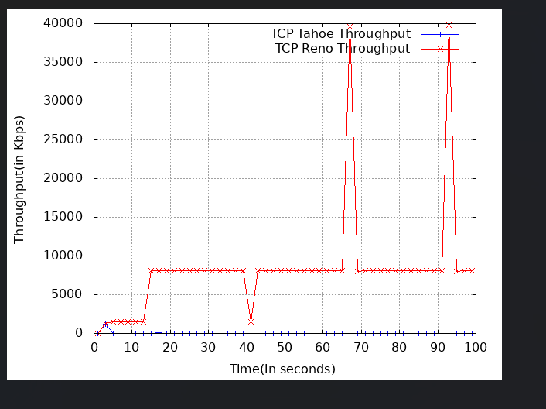

1. **Delay graph (Tahoe vs reno)**

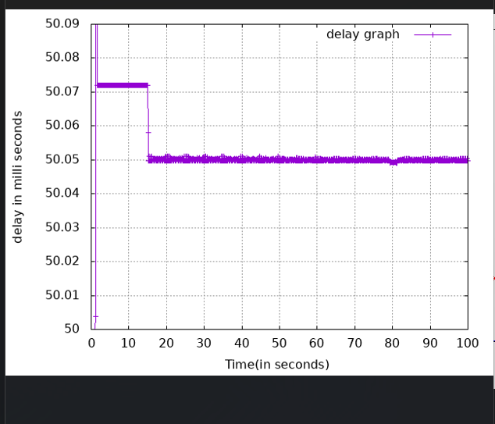

1. **Pkt loss ratio (tahoe Vs reno)**

Here, sender’s bandwidth is reduced to 300Kbps from 300Mbps and

Bottleneck bandwidth is reduced to 50Kbps from 500Mbps, in order to

Obtain dropped packets.

Remaining code part will be same.

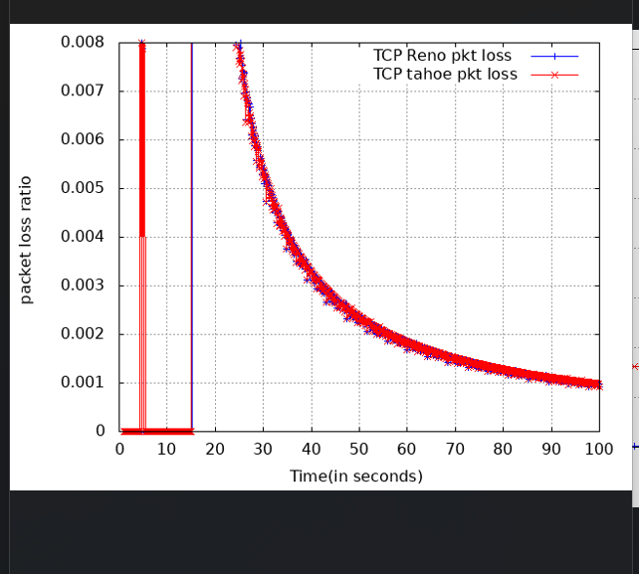

1. **Jain fairness Index (TCP vs Reno)**

